PROBLEM SOLVING AND TESTING USING JAVA

NAME: L.RITHWIKA REDDY
VTU NO: 29439
WEEK 4 PROBLEMS

SESSION 1:-
https://leetcode.com/problems/determine-if-string-halves-are-alike/
class Solution {
public boolean halvesAreAlike(String s) {
int mid = s.length() / 2;
int countA = 0;
int countB = 0;

for (int i = 0; i < mid; i++) {
if (isVowel(s.charAt(i))) {
countA++;
}
}

for (int i = mid; i < s.length(); i++) {
if (isVowel(s.charAt(i))) {
countB++;
}
}

return countA == countB;
}

private boolean isVowel(char c) {
return c == 'a' || c == 'e' || c == 'i' || c == 'o' || c == 'u'
|| c == 'A' || c == 'E' || c == 'I' || c == 'O' || c == 'U';
}
}
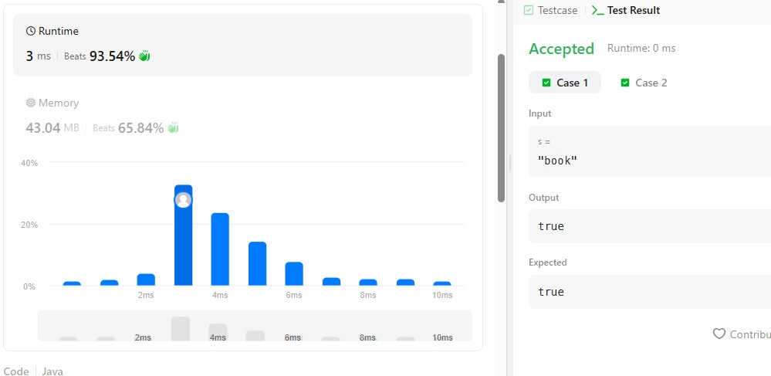
SESSION 2:-
2.1:- https://www.hackerrank.com/challenges/compare-the-triplets/problem
import java.util.*;

public class Solution {

public static List<Integer> compareTriplets(List<Integer> a, List<Integer> b) {
int alice = 0;
int bob = 0;

for (int i = 0; i < 3; i++) {
if (a.get(i) > b.get(i)) {
alice++;
} else if (a.get(i) < b.get(i)) {
bob++;
}
}

return Arrays.asList(alice, bob);
}

public static void main(String[] args) {
Scanner sc = new Scanner(System.in);

List<Integer> a = new ArrayList<>();
List<Integer> b = new ArrayList<>();

for (int i = 0; i < 3; i++) {
a.add(sc.nextInt());
}

for (int i = 0; i < 3; i++) {
b.add(sc.nextInt());
}

List<Integer> result = compareTriplets(a, b);

System.out.println(result.get(0) + " " + result.get(1));

sc.close();
}
}
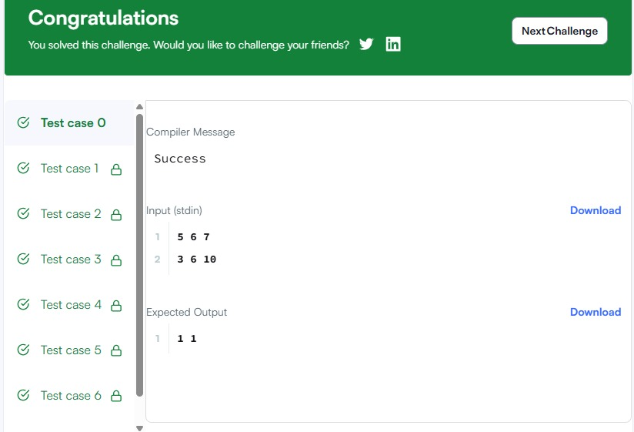
2.2:- https://leetcode.com/problems/contains-duplicate/
import java.util.HashSet;
import java.util.Set;

class Solution {
public boolean containsDuplicate(int[] nums) {
Set<Integer> set = new HashSet<>();

for (int num : nums) {
if (set.contains(num)) {
return true;
}
set.add(num);
}

return false;
}
}
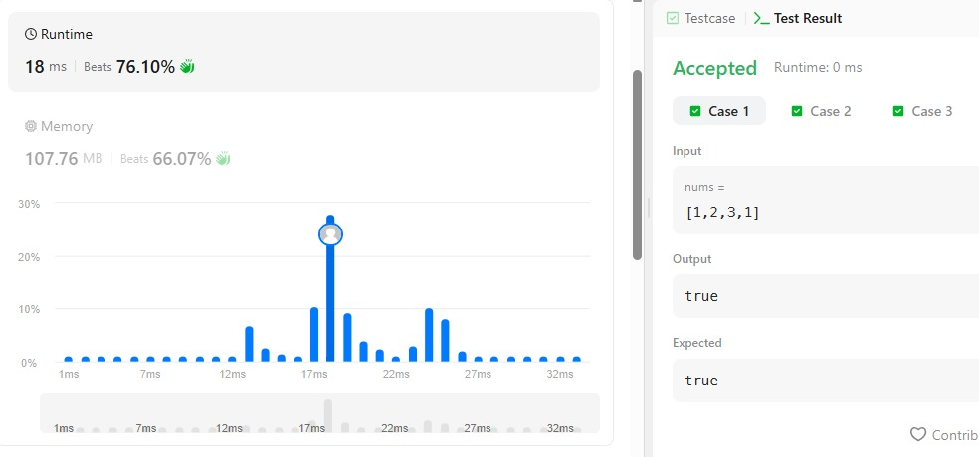
SESSION 3:-
3.1:- https://www.hackerrank.com/challenges/time-conversion/problem
import java.util.*;

public class Solution {

public static String timeConversion(String s) {
int hour = Integer.parseInt(s.substring(0, 2));
String period = s.substring(8, 10);

if (period.equals("AM")) {
if (hour == 12) {
hour = 0;
}
} else { // PM
if (hour != 12) {
hour += 12;
}
}

return String.format("%02d", hour) + s.substring(2, 8);
}

public static void main(String[] args) {
Scanner sc = new Scanner(System.in);

String s = sc.nextLine();

System.out.println(timeConversion(s));

sc.close();
}
}
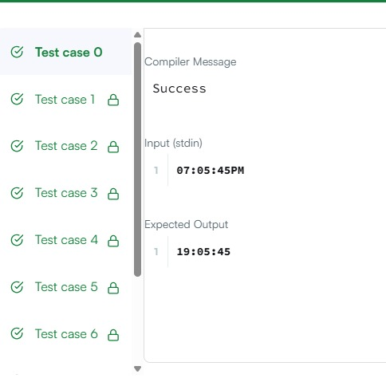
3.2:- https://leetcode.com/problems/move-zeroes/
class Solution {
public void moveZeroes(int[] nums) {
int index = 0;

// Move all non-zero elements to the front
for (int i = 0; i < nums.length; i++) {
if (nums[i] != 0) {
nums[index] = nums[i];
index++;
}
}

// Fill the remaining positions with zeros
while (index < nums.length) {
nums[index] = 0;
index++;
}
}
}
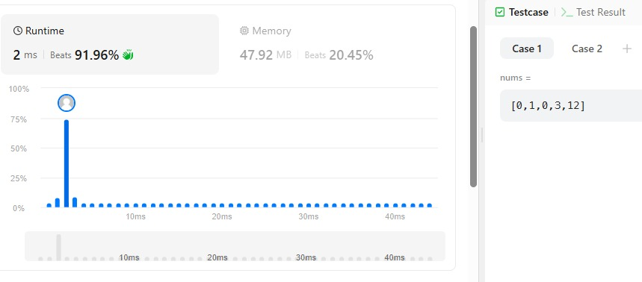

SESSION 4:-
4.1:- https://www.hackerrank.com/challenges/diagonal-difference/
import java.util.*;

public class Solution {

public static int diagonalDifference(List<List<Integer>> arr) {
int n = arr.size();

int primarySum = 0;
int secondarySum = 0;

for (int i = 0; i < n; i++) {
// Primary diagonal: [i][i]
primarySum += arr.get(i).get(i);

// Secondary diagonal: [i][n - 1 - i]
secondarySum += arr.get(i).get(n - 1 - i);
}

return Math.abs(primarySum - secondarySum);
}

public static void main(String[] args) {
Scanner sc = new Scanner(System.in);

int n = sc.nextInt();

List<List<Integer>> arr = new ArrayList<>();

for (int i = 0; i < n; i++) {
List<Integer> row = new ArrayList<>();

for (int j = 0; j < n; j++) {
row.add(sc.nextInt());
}

arr.add(row);
}

System.out.println(diagonalDifference(arr));

sc.close();
}
}
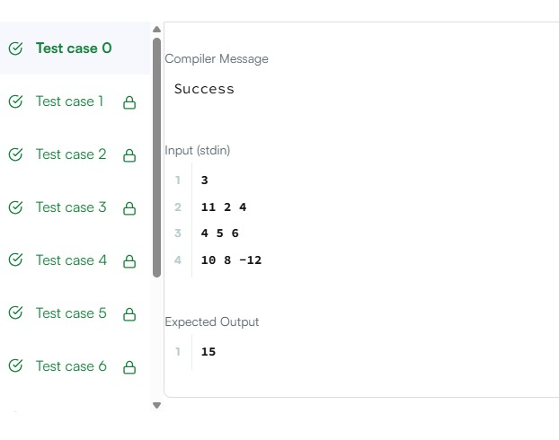
4.2:- https://leetcode.com/problems/transpose-matrix/
class Solution {
public int[][] transpose(int[][] matrix) {
int m = matrix.length;
int n = matrix[0].length;

int[][] result = new int[n][m];

for (int i = 0; i < m; i++) {
for (int j = 0; j < n; j++) {
result[j][i] = matrix[i][j];
}
}

return result;
}
}
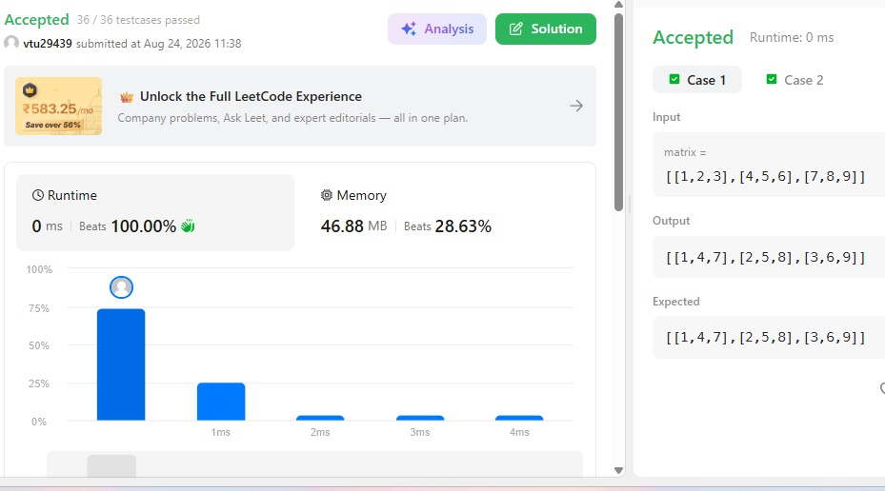
SESSION 5:-
5.1:- https://leetcode.com/problems/matrix-block-sum/
class Solution {
public int[][] matrixBlockSum(int[][] mat, int k) {
int m = mat.length;
int n = mat[0].length;

int[][] answer = new int[m][n];

for (int i = 0; i < m; i++) {
for (int j = 0; j < n; j++) {

int sum = 0;

int rStart = Math.max(0, i - k);
int rEnd = Math.min(m - 1, i + k);

int cStart = Math.max(0, j - k);
int cEnd = Math.min(n - 1, j + k);

for (int r = rStart; r <= rEnd; r++) {
for (int c = cStart; c <= cEnd; c++) {
sum += mat[r][c];
}
}

answer[i][j] = sum;
}
}

return answer;
}
}
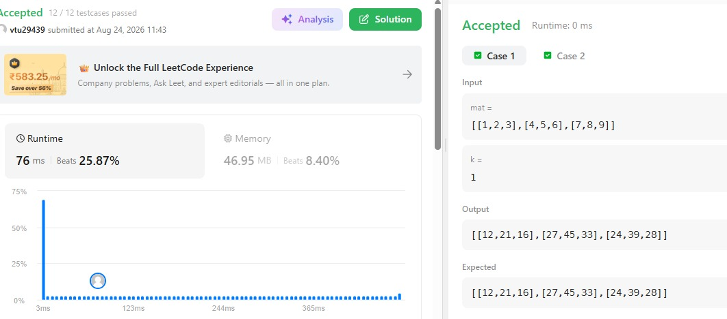
5.2:- https://www.hackerrank.com/challenges/matrix-rotation-algo/
import java.util.*;

public class Solution {

public static void matrixRotation(List<List<Integer>> matrix, int r) {
int m = matrix.size();
int n = matrix.get(0).size();

// Number of layers
int layers = Math.min(m, n) / 2;

for (int layer = 0; layer < layers; layer++) {

// Store elements of the current layer
List<Integer> elements = new ArrayList<>();

int top = layer;
int left = layer;
int bottom = m - layer - 1;
int right = n - layer - 1;

// Top row: left -> right
for (int j = left; j <= right; j++) {
elements.add(matrix.get(top).get(j));
}

// Right column: top+1 -> bottom
for (int i = top + 1; i <= bottom; i++) {
elements.add(matrix.get(i).get(right));
}

// Bottom row: right-1 -> left
for (int j = right - 1; j >= left; j--) {
elements.add(matrix.get(bottom).get(j));
}

// Left column: bottom-1 -> top+1
for (int i = bottom - 1; i > top; i--) {
elements.add(matrix.get(i).get(left));
}

int len = elements.size();
int rotation = r % len;

// Anti-clockwise rotation:
// element at index i moves to (i - rotation)
List<Integer> rotated = new ArrayList<>(Collections.nCopies(len, 0));

for (int i = 0; i < len; i++) {
rotated.set((i - rotation + len) % len, elements.get(i));
}

int index = 0;

// Put elements back into the matrix

// Top row
for (int j = left; j <= right; j++) {
matrix.get(top).set(j, rotated.get(index++));
}

// Right column
for (int i = top + 1; i <= bottom; i++) {
matrix.get(i).set(right, rotated.get(index++));
}

// Bottom row
for (int j = right - 1; j >= left; j--) {
matrix.get(bottom).set(j, rotated.get(index++));
}

// Left column
for (int i = bottom - 1; i > top; i--) {
matrix.get(i).set(left, rotated.get(index++));
}
}

// Print result
for (List<Integer> row : matrix) {
for (int j = 0; j < row.size(); j++) {
System.out.print(row.get(j));
if (j < row.size() - 1) {
System.out.print(" ");
}
}
System.out.println();
}
}

public static void main(String[] args) {
Scanner sc = new Scanner(System.in);

int m = sc.nextInt();
int n = sc.nextInt();
int r = sc.nextInt();

List<List<Integer>> matrix = new ArrayList<>();

for (int i = 0; i < m; i++) {
List<Integer> row = new ArrayList<>();

for (int j = 0; j < n; j++) {
row.add(sc.nextInt());
}

matrix.add(row);
}

matrixRotation(matrix, r);

sc.close();
}
}
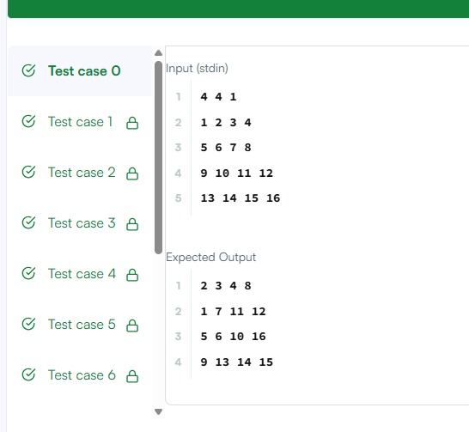

THANK YOU

